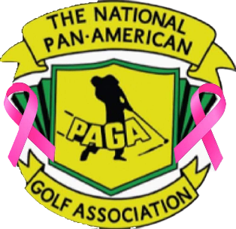
2022 National PAGA 3rd Delegates Meeting/Workshop and Tournament
Hosted by PAGA of Irving
October 7-8, 2022

Come out to Irving, TX for the last NPAGA event of the year and
celebrating the 75th PAGA Anniversary

Delegates Meeting: Friday October 7, 2022
Atrium Hotel & Suites DFW Airport – Conference Center
4600 W. Airport Freeway Irving, TX 75062

Golf Tournament: Saturday October 8, 2022
Bear Creek GC (West Course) – Euless, TX
8am shotgun start, 128 golfers
$110 per player includes breakfast and lunch, range balls, CTTP ($200 awarded to CTTP winner, 1 winner per flight, 4 flights)
Optional wagering - $20, flighted skins - $20, super skins - $20
(Bear Creek has an additional 18-hole course if needed)

Hotel: Atrium Hotel & Suites DFW Airport
4600 W. Airport Freeway Irving, TX 75062
Tel. - 972.513.0800 – ROOMS BLOCKED UNDER “PAGA”
$109 plus tax (King or 2 Queen Beds) Breakfast included
DFW Airport: 3 miles away – free shuttle to DFW Airport
Bear Creek GC: 5 miles away

Dallas Area Attractions
Texas Rangers Baseball (NY Yankees vs Texas Oct. 3-5, 2022)
Dallas Cowboys, State Fair of Texas, Texas-OU weekend, Six Flags over Texas,
JFK Memorial, Deep Ellum, Dallas Farmers Market, Dallas Aquarium, Dallas Zoo,
Bishop Arts District, Texas Live, Lone Star Park, Las Colinas, Toyota Music Factory

