President: Onesimo Castillo

Vice Pres: Javier Leal

Treasurer: Agapito Alaniz

Secretary: Joe Muñoz

Handicap Chairman & Tournament Director: Jimmy Vera & Javier Leal

ALICE MUNICIPAL GOLF COURSE

2290 North Texas Blvd.

Alice, Texas 78332

(361) 664-7033

Mgr.: Joe Hernandez

USGA RULES APPLY

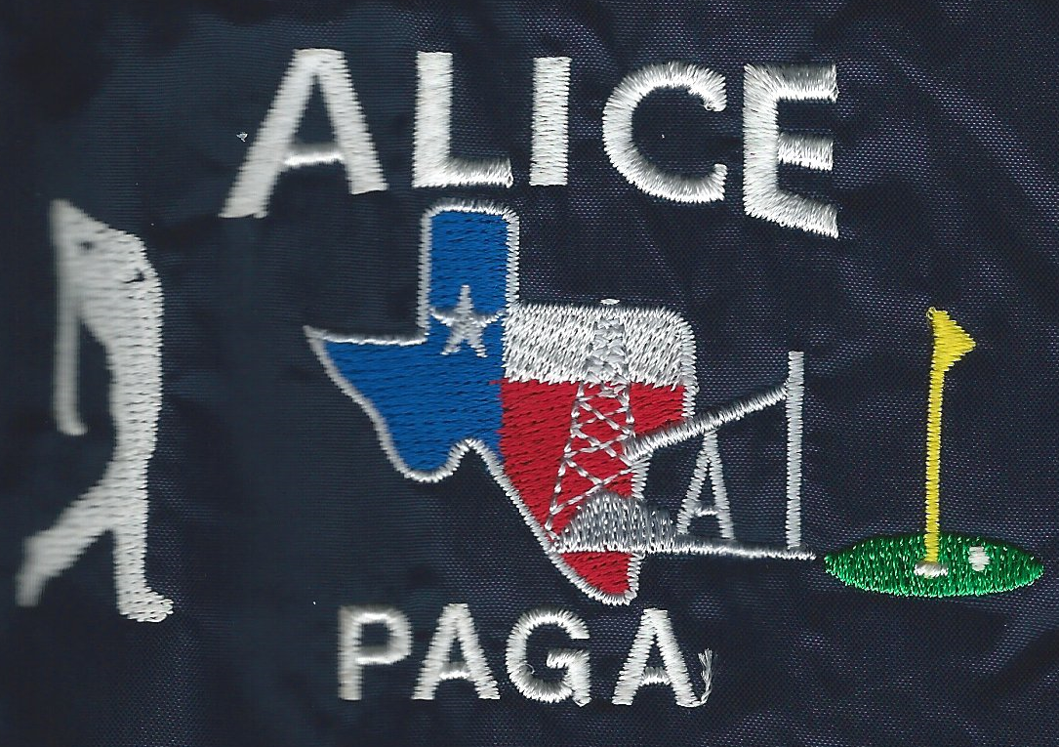

**Format: Individual Medal Play, "net score" (with full handicap) and four "equal" flights ‘’ Limited to first 80 paid players ’’**

**Fees: $70.00 per player**

**Skins: Optional $20.00 per Flt**

**Includes: Green, Cart Fee**

**Great Lunch & Drinks**

**Registration Deadline: “” Oct.08, 2015””**

**Date: October 11, 2015**

**Registration: 7:00 am – 8:00 am**

**Shot Gun Start: 8:30 am**

**\*\*\* Cash Prizes \*\*\***

Contact: Jimmy Vera “Tournament Director”

Email: [jimmy_vera@yahoo.com](mailto:jimmy_vera@yahoo.com)

Phone: 361-227-5602

Contact: Joe Munoz “Secretary - Delegate”

Email: [munoz5578@stx.rr.com](mailto:munoz5578@stx.rr.com)

Phone: 361-668-3306

Contact: Onesimo Castillo “President”

Email: [castillo_onesimo@yahoo.com](mailto:castillo_onesimo@yahoo.com)

Phone: 361-227-0776

Alice PAGA

Is proud to host the 2015

South Texas Classic

Bring your own Team!

A-B-C-D Team

If you don’t have a team, you will be assigned to one.

Limited to 84 players

Invitational Tournament

“Scholarship”

Fundraiser